1. **Steps to push and retrieve code from Local to Git** **and git to local**  
     
   Step :1 Initialize local folder to creates a new Git repository.  
   **git init**  
     
   Step2: Check the status of the folder to Displays paths that have differences between the index file and the current HEAD commit.  
   **git status  
     
   Step**3: Add files to the staging area by using the "git add" command and passing necessary options. **git add .  
     
   Step 4 :** Commit and push changes. After you've added new files to the Git repository. **git commit -m “Add comments adding the first commit”**

Step 5: Adding the files and folder in Git at specific folder.  
 **git remote add origin** [**https://github.com/pankajmissguided/qa-exercise.git**](https://github.com/pankajmissguided/qa-exercise.git)

Step 6 : push the file to git  
**git push origin master  
  
Steps to download folder from Git to local computer**

**Step1:** Create a local folder in computer  
  
Step2: initialize git to local folder  
 **git init  
  
Step3:** Login to your local git  
  
Step 4: Go to the git specified folder and click on button Clone/download and copy the link  
  
Step5: Cloning the file from git to local computer  
**git clone “past the copied link here”**  
  
  
  
Step 7: check all files and folder to local go to the specific folder in local computer and check all files copied successfully.

1. Download Java latest version to the machine
2. Download Eclipse to the machine.
3. Running the exercise to the machine  
   Step1. Go to Menu >**FILE > Import> Maven>Existing maven Projects** and select **Next button**Step2**.** Select **Root Directory “**local folder location where saves the file in machine**” Tick** the checkbox **“Add projects to working set” and finally** click on **Finish Button.**click

**Step3. Go to folder target >pom.xml** right click select **Run AS** click option **Maven clean (it starts running the build)** And thenselect **Maven Install** (this ‘ll start running the exercise)**.**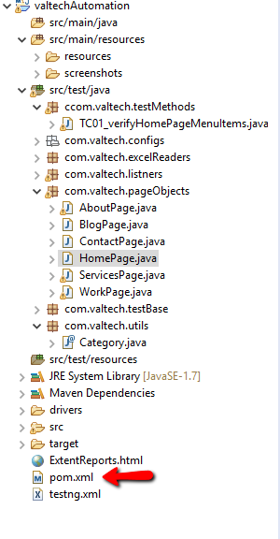

**Step 4.** Rt.Click on the main folder **ValtechAutomation** and click **refresh  
Step 5.** Go to **ExtentReports.html Rt.click >OpenWith>WebBrowser   
This ‘ll run the reports of the test case run Pass/Fail.**